# Design 1

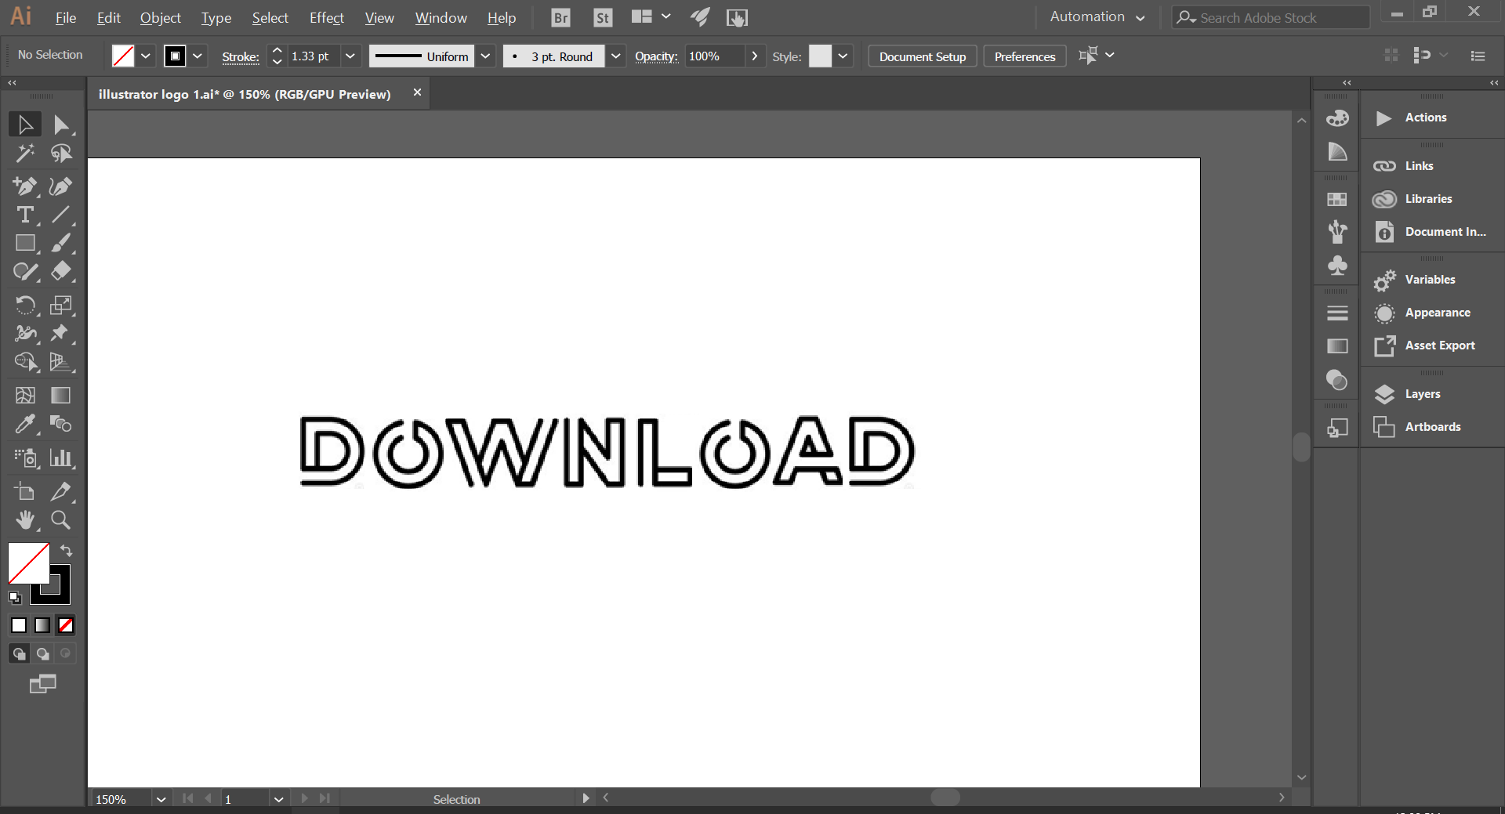

First, I imported an image of the font I’m going to use, with the word “Download” already spelt out. I did this simply by copying and pasting the image into illustrator(ctrl + C, ctrl + V) This is so that I can trace over the images using segments of circles for parts of letters on ‘D’ and ‘O’, and the line tool for the other parts.

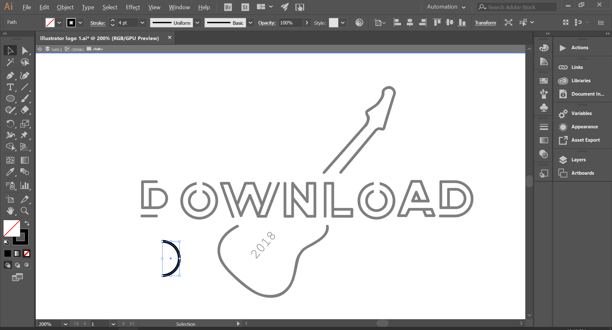

Here you can see that a circle has been cut in half, which is used on the curved segments of the letter ‘D’

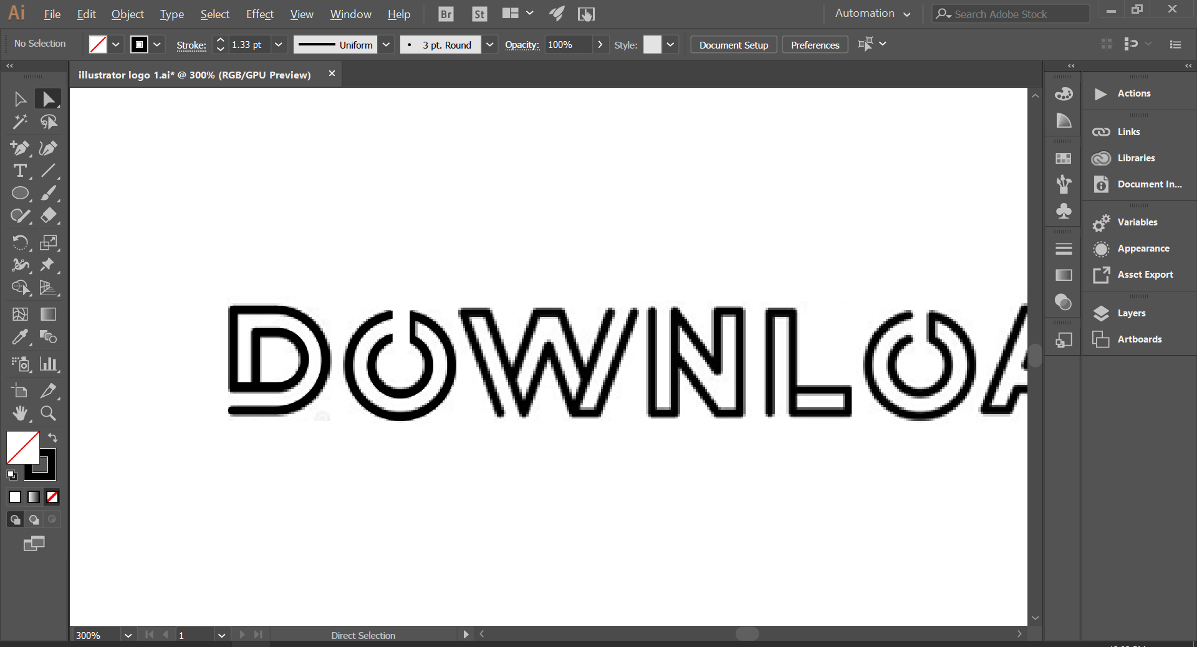

This is partway through the process of tracing, where the letter ‘O’ has now been traced. Its not clear hear but the background image and the tracing are both on the screen. The letters appear fuzzy due to the anti-aliasing on the image I am tracing.

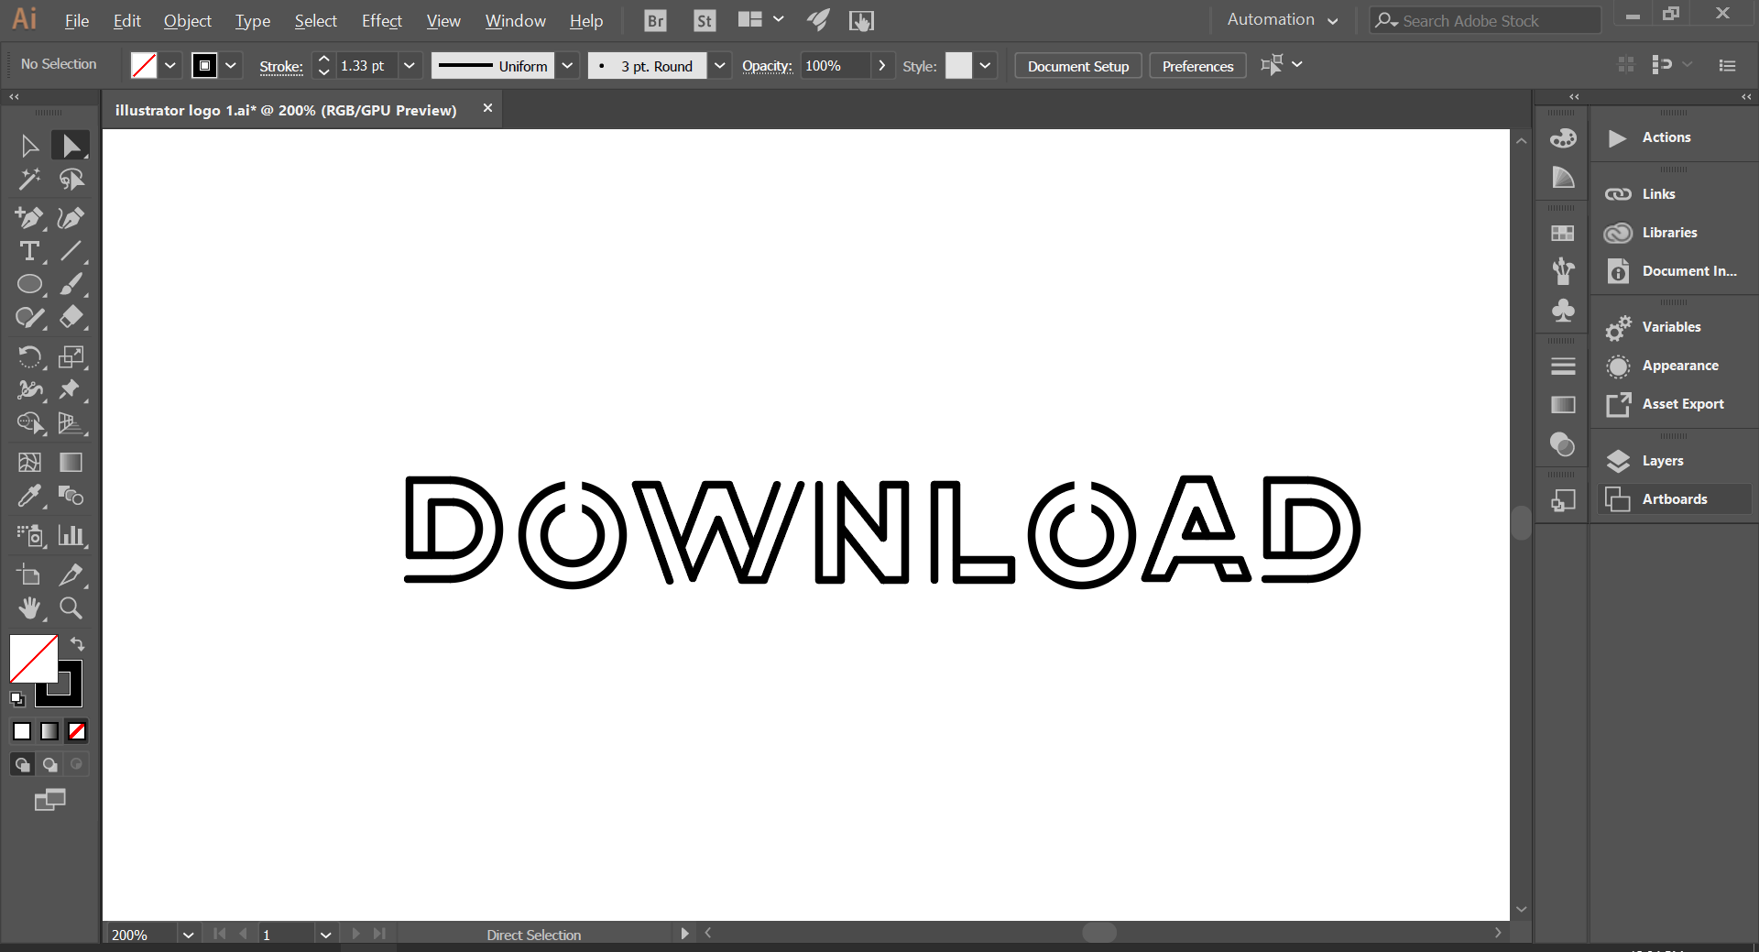

This is after all the letters have been traced, with the writing now finished, I can move onto the guitar. The background font has been removed at this point, however I just hid the layer rather than deleting the image in case I need it again later.

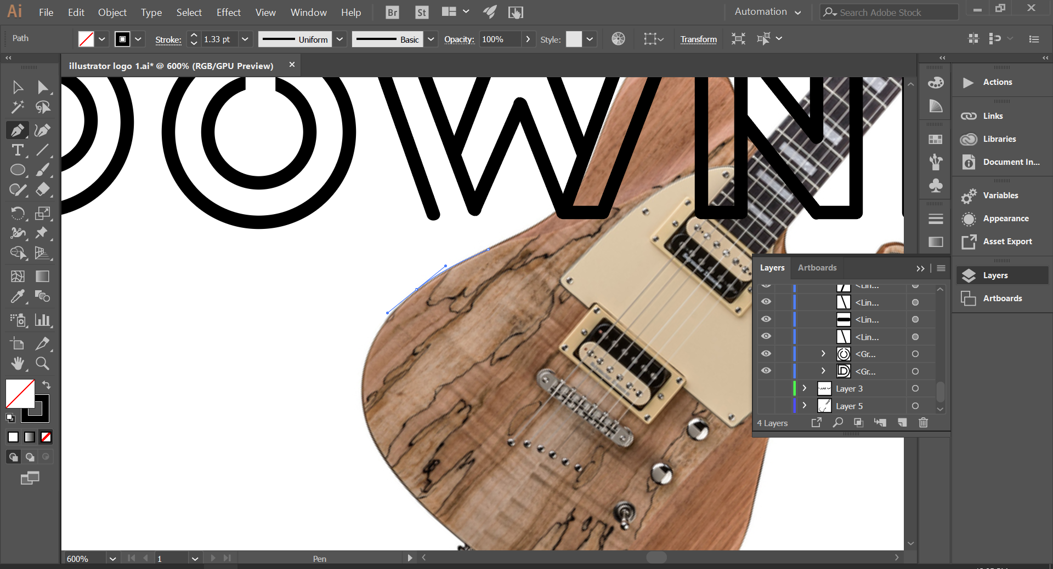

I imported an image of a guitar from google images and started to trace around it is using the pen tool. By holding left click and dragging, I was able to create curved segments which allowed me to follow the curves of the guitar with the tool.

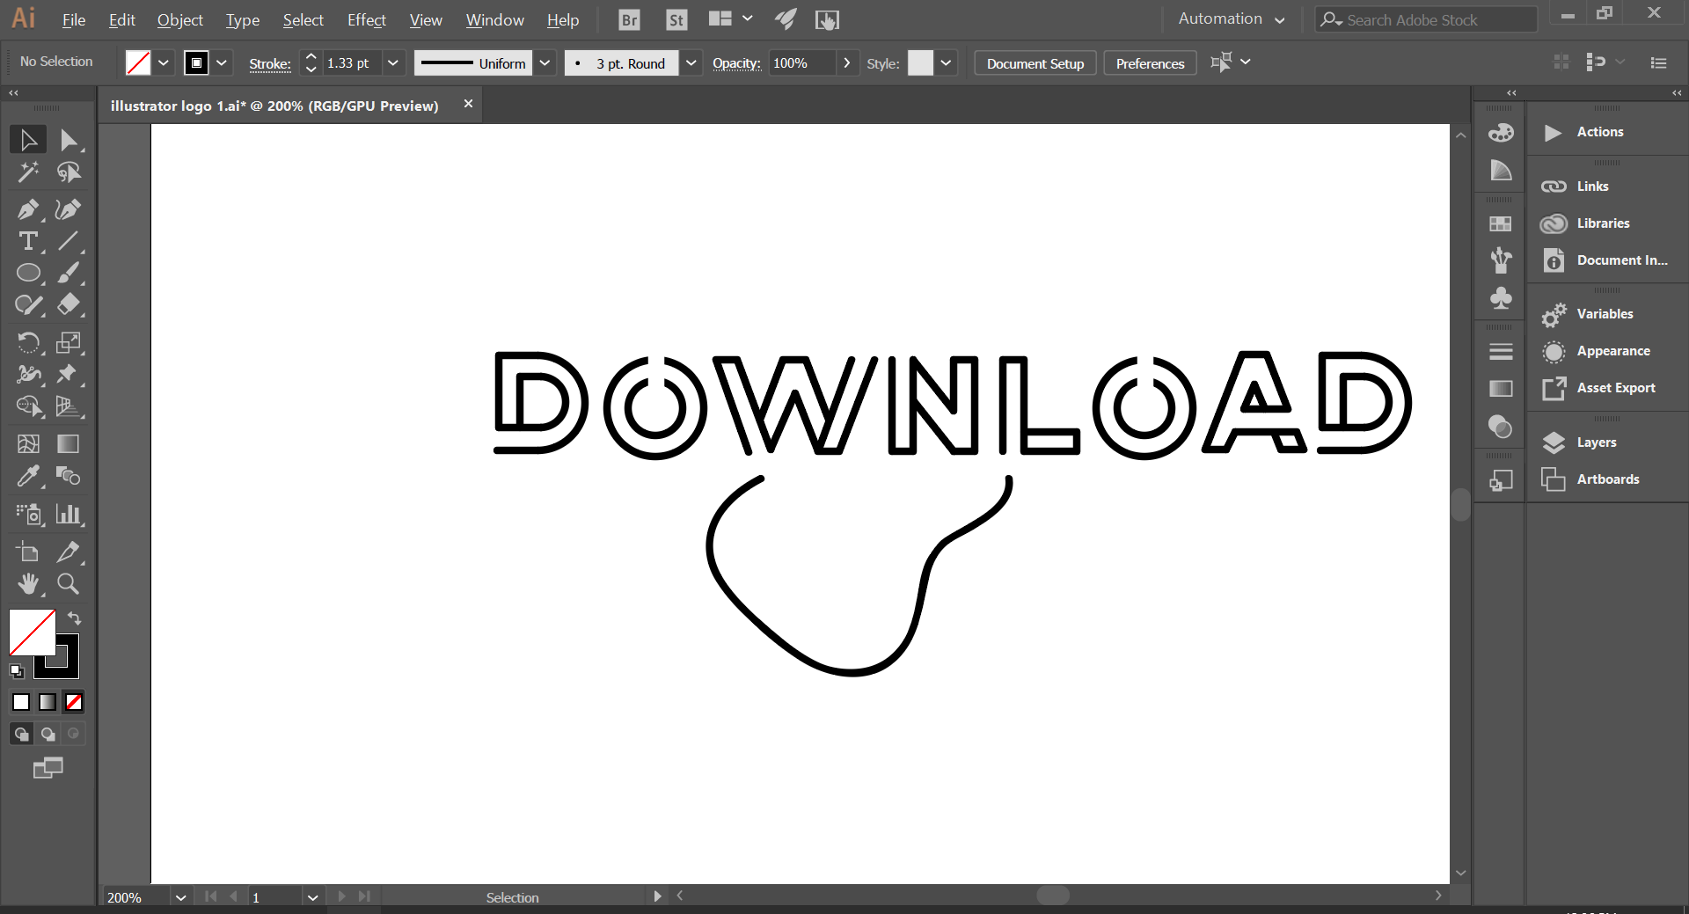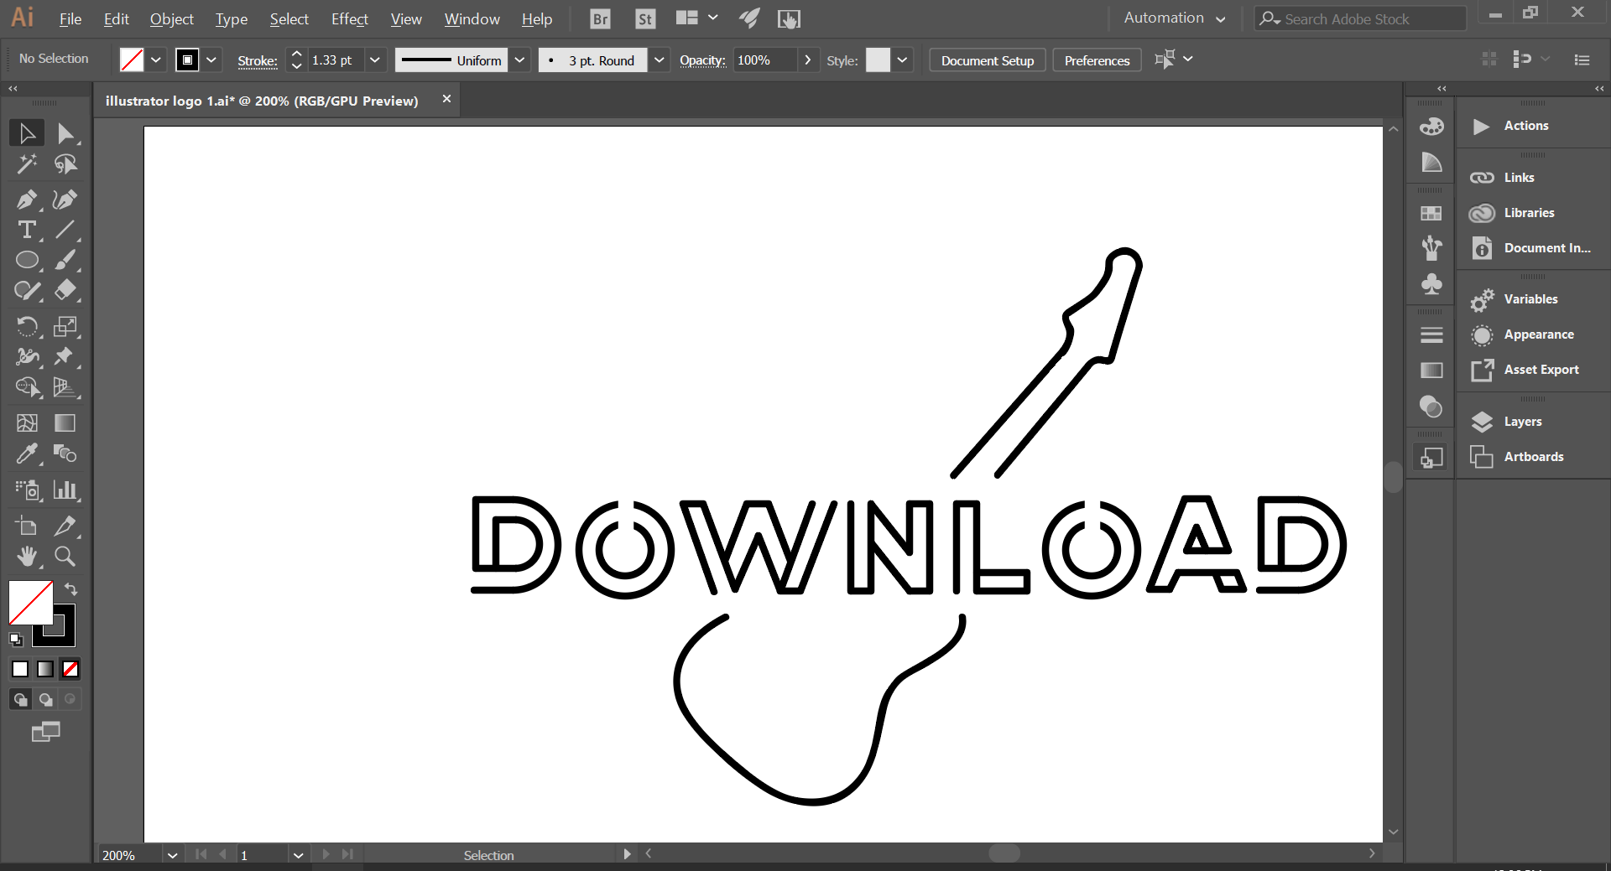



The finished logo is very minimalist, and visually appealing. Although there isn’t a lot of detail on the guitar itself, the shape is very clear and its easy to see that it’s a guitar. This links the logo back to the festival has it is a rock and metal festival, which heavily features guitars.